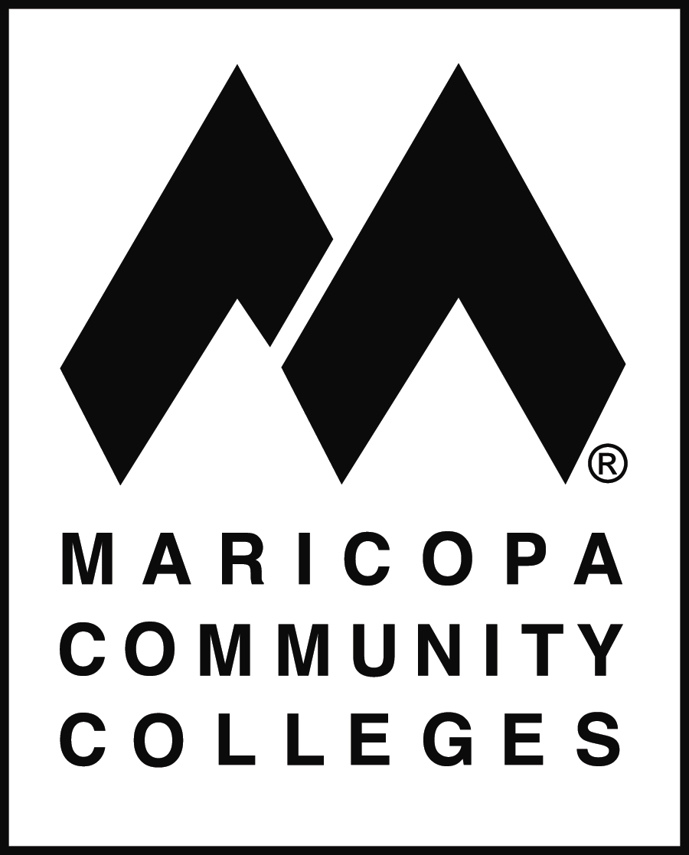
MARICOPA COUNTY COMMUNITY COLLEGE DISTRICT
2411 West 14th Street, Tempe, AZ 85281-6942

EXPERIENTIAL EDUCATION
ASSUMPTION OF RISK & RELEASE OF LIABILITY

Caution: This is a release of legal rights. Read and understand it before signing.

The Maricopa County Community College District is a public educational institution. References to College ("College") include all of the Colleges within the Maricopa County Community College District ("MCCCD"), its officers, officials, employees, volunteers, students, agents, and assigns.

I _______________________________, will be participating as a experiential education student at ____________________________ (henceforth referred to as the “Program”) from _________________ to _________________.

In consideration of my participation in this Program, I agree as follows:

RISK OF PROGRAM ACTIVITIES: I understand that my participation in the College Program specified above involves risks of physical harm and injury inherent in service activities including, but not limited to, working with people, participating in sports and recreation activities, cleaning and maintenance projects, preparing and serving food, and other service activities.

INSTITUTIONAL ARRANGEMENTS: I understand that College is not an agent of, and has no responsibility for, any third party that I may provide any Program services to. I understand that College provides guidance and facilitates my Program activities only as a component of my experiential education experience and that accordingly, College accepts no responsibility, in whole or in part, for loss, damage or injury to persons or property whatsoever, caused to me or others while participating in the Program. I further understand that College is not responsible for matters that are beyond its control.

INDEPENDENT ACTIVITY: I understand that College is not responsible for any loss or damage I may suffer when I am doing Program activities and that College cannot and does not guarantee my personal safety. In addition, I specifically acknowledge that in performing Program activities, I am doing so independently in the status of student of the Program I choose, and not as an employee, or agent of College. I further waive any and all claims which may arise from such Program activities, acknowledge that workers’ compensation benefits are not provided to me in my capacity as a student, and hold College harmless from any of my negligent acts. I further state that I am not in any way an employee of College in any capacity.

I further agree that I am solely responsible for my own equipment, supplies, personal property, and effects during the course of Program activities.

In addition, I agree that if I drive or provide my own motor vehicle for transportation to, during, or from the Program site, I am responsible for my own acts and for the safety and security of my own vehicle. I accept full responsibility for the liability of myself and my passengers, and I understand that if I am a passenger in such a private vehicle, College is not in any way responsible for the safety of such transportation and that College’s insurance does not cover any damage or injury suffered in the course of traveling in such a vehicle.

HEALTH AND SAFETY: I have been advised to consult with a medical doctor with regard to my personal medical needs. I state that there are no health-related reasons or problems that preclude or restrict my participation in this Program. I have obtained the required immunizations, if any.

I understand that I may be required to pay up front for my medical expenses that I incur while participating in this Program. Further, I understand that I am responsible to submit any medical receipts to my insurance carrier upon my return. I recognize that College is not obligated to attend to any of my medical or medication needs, and I assume all risk and responsibility therefore. College may (but is not obligated to) take any actions it considers to be warranted under the circumstances regarding my health and safety. I agree to pay all expenses relating thereto and release College and MCCCD from any liability for any actions.

Participating in any activity is an acceptance of some risk of injury. I agree that my safety is primarily dependent upon taking care of myself. I understand that it is my responsibility to know what personal equipment is required (such as footwear, clothing, and other personal protective equipment) and provide the proper personal equipment for my participation in the Program, and to ensure that it is good and suitable condition. I agree to ask questions to make sure that I know how to safely participate in the Program activities, and I agree to observe the rules and practices which may be employed to minimize the risk of injury while participating in the Program activities. I agree to reduce the risk of injury to myself or others by limiting my participation to reflect my personal fitness level, wearing the proper protection as dictated by the activity, not wearing anything that would pose a hazard in the performance of the activity, not ingesting or using any substance during the activity which could pose a hazard to myself or others. I agree that if I fail to act in accordance with this agreement that I may not be permitted to continue to participate in the activity.

ASSUMPTION OF RISK AND RELEASE OF LIABILITY: I understand that I may be injured and lose or damage personal property as a result of participation in the Program. Therefore, I assume all risks related to the Program activities. Knowing the risks described above, and in consideration of being permitted to participate in the Program, I agree to release, indemnify, and defend College and MCCCD and their officials, officers, employees, agents, volunteers, sponsors, and students from and against any claim which I, the participant, my parents or legal guardian or any other person may have for any losses, damages or injuries arising out of or in connection with my participation in this Program.

SIGNATURE: I indicate that by signature below that I have read the terms and conditions of participation and agree to abide by them. I have carefully read this Agreement and acknowledge that I understand it. No representation, statements, or inducements, oral or written, apart from the foregoing written statement, have been made. This Agreement shall be governed by the laws of the State of Arizona which shall be the venue for any lawsuits filed under or incident to this Agreement or to the Program. If any portion of this Agreement is held invalid, the rest of the document shall continue in full force and effect.

Signature of Program Participant |  | Date

Signature of Parent or Legal Guardian (if student is a minor) |  | Date

