Lab 9: Numerical Integration

Goal
Students will approximate the area under a curve and evaluate definite integrals using Riemann sum approximations and limits.

Discussion
Consider the area bounded by a continuous function y = f(x), the x-axis, and vertical lines x = a and x = b. Usually there is not a simple formula for such an area. The area can be approximated by a sum of rectangles, a Riemann sum. The approximation will be closer to the desired area when a large number of small rectangles is used. Maple will be used to do the numerical computations for the Riemann sums. The limit of the Riemann sums will also be considered.

Area Example
We are going to approximate the area bounded by the curve f(x) = , the x-axis, and the vertical lines x = 1 and x = 3.
> f:=10-x^2;

To run the commands for approximations Maple requires the loading of one of its library packages.
> with(student);

We will have Maple divide the interval [1,3] into n = 4 equal subintervals of length 1/2 and approximate the area under the curve with rectangles using the right endpoints.
> rightbox(f,x=1..3,4);

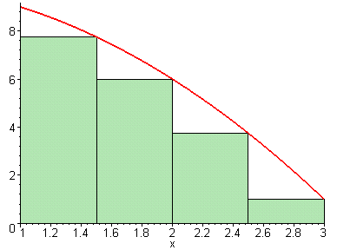

> rightsum(f,x=1..3,4);

> evalf(%);

This is the sum of the areas of the inscribed rectangles. This number is clearly smaller than the desired area. Now you redo the above commands using more rectangles: replace n = 4 with n=20. Then redo the commands with n =50, then n=100. What is the limit of the areas as n gets larger?
> limit(rightsum(f,x=1..3,n),n=infinity);

Next we will approximate the area using n=4 with the left endpoints.
> leftbox(f,x=1..3, 4);

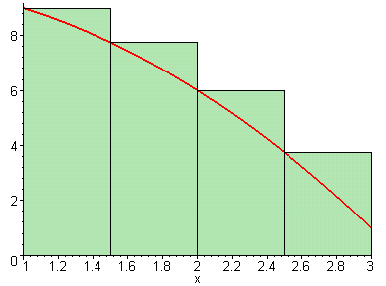

> leftsum(f,x=1..3,4);

> evalf(%);

This is the sum of the areas of the circumscribed rectangles; it is larger than area under the curve y = f(x). Now you redo the above commands using more rectangles: replace
n = 4 with n=20. Then redo the commands with n= 50, then n=100. What is the limit of the areas as n gets larger?
> limit(leftsum(f,x=1..3,n),n=infinity);

We will do more approximations.
> middlebox(f,x=1..3,4);

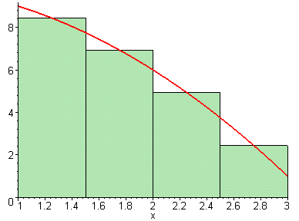

> middlesum(f,x=1..3,4);

> evalf(%);

Now you redo the above commands using more rectangles; replace n= 4 with n=20. Then redo the commands with n=50, then n=100. What is the limit of the areas as n gets larger?
> limit(middlesum(f,x=1..3,n),n=infinity);

Note that the limits from rightsum, leftsum, and middlesum are all the same. This is the area bounded by the curve, the x-axis, and the vertical lines x = 1 and x = 3. It is denoted by $\int_{1}^{3}{(\text{10}−x^{2})\text{dx}}$. . Below is Maple's command to evaluate this definite integral.
> int(f,x=1..3);

Riemann Sum Example
The definite integral $\int_{a}^{b}{f(x) \text{dx}}$ is defined as $\underset{n→∞}{\text{lim}}\sum_{i=1}^{n}{f(x_{i}^{})Δx}$, where the interval
[a, b] is subdivided into n equal subintervals and $x_{i}^{}$is a point in the $i^{\text{th}}$subinterval. This definition does not depend on whether the function is positive or negative. We can use Maple to evaluate Riemann Sums and limits without considering whether the result is an
area.

Consider the integral . Although this integral represents the area between the x-axis and the graph of on the interval [0,5], we will evaluate it using sums and limits. Using =5/n and right endpoints $x_{1}=\frac{5}{n}$, $x_{2}=2\left(\frac{5}{n}\right)$,…,$x_{i}=i\left(\frac{5}{n}\right)$,…the integral can be represented by . To evaluate the sum portion of this expression, use the following commands.
> Sum((5*i/n)^2*(5/n),i=1..n);

> value(%);

Now, to evaluate the limit, use the following commands.
> limit(%,n=infinity);

To evaluate the limit of the sum all at once, use the following commands.
> limit(Sum((5*i)^2/(n^2)*5/n,i = 1 .. n),n = infinity);

Let's consider another integral. $\int_{1}^{4}{\left(x^{2}+2x+5\right)} \text{dx}$.
> f:=x->x^2+2*x+5;

The interval [1,4] is subdivided into n equal subintervals of length = (4-1)/n =3/n. The right endpoints of the subintervals are
$x_{1}=1+\frac{3}{n}$, $x_{2}=1+2\left(\frac{3}{n}\right)$ ,…, $x_{i}=1+i\left(\frac{3}{n}\right)$,...
> Sum(f(1+i*(3/n))*(3/n),i=1..n);

> limit(%,n=infinity);

Lab Assignment 9

Start the lab by putting your name on the first line. WRITE DOWN THE INSTRUCTION FOR EACH QUESTION AND ANSWER ALL QUESTIONS COMPLETELY IF YOU WANT FULL CREDIT!!!. When you complete the lab, hand in a printout of it and circle your answers.

1. Consider the area of the region R bounded by the graph of f(x) = ,
the x-axis, and the vertical lines x = 0 and x = 6.

a) Use rightbox to obtain a graph of f(x)= together with n = 4
rectangles. Then use rightsum to calculate the area inside the 4 rectangles.

b) Determine the terms that occurred in the area in part (a), using n = 4 and right
endpoints, by completing the following table - a Maple spreadsheet.
Hint: If you have f defined as an expression, consider making f into
a function before you do the spreadsheet.

 | A | B | C
1
2
3
4
5

Find the sum of the entries in the right column. The sum should be the same as
the area in part (a).

c) Use rightsum to calculate the area inside the rectangles for n = 10, 20, and 30.
Recall that the rightsum command uses expressions.
Estimate the limit as $n→∞$.

d) Use leftbox to graph f(x) together with n = 4 rectangles. Then use
leftsum to calculate the area inside the 4 rectangles.
e) Determine the terms that occurred in the area in part (d), using n = 4
and left endpoints, by completing the following table - a Maple spreadsheet.

 | A | B | C
1
2
3
4
5

Find the sum of the entries in the right column. The sum should be the same as
the area in part (d).

f) Use leftsum to calculate the area inside the rectangles for n = 10, 20, and 30.
Estimate the limit as n increases.

g) Use Maple's int to find the area.

2. Use the Riemann Sum limit definition to investigate $\int_{1}^{5}{\left(x^{3}+2x\right) \text{dx}}$.
by entering the Riemann Sum as sum( ________________ ,i=1..n)
followed by limit(______________ , n=infinity)

a) using right end points.

b) using left end points.

