LAB 8: Graphing Using Derivatives

Goals
1. Students will use the zeros of the first derivative to find the local maximums
and minimums of a function f.
2. Students will use the zeros of the second derivative to find the inflection points
of a function f .

Discussion
The first and second derivatives of a function f determine some of the properties of f. Local maximums and minimums of f occur at the zeros of the first derivative. The inflection points of f occur at the zeros of the second derivative. Maple will be used to find the derivatives. The graphs of f and its derivatives will be compared.

Example
Consider the following function, defined as an expression in Maple.
> f:=x^2*exp(x);

Next we will calculate the first derivative and call it Df. Then we will factor the first derivative to find the critical values of f.
> Df:=diff(f,x);

> factor(Df);

> solve(Df=0,x);

These are x-values. We want the corresponding y-values.
> subs(x=-2,f);

> evalf(%);

> subs(x=0,f);

> plot([f,Df],x=-4..4, y =-2..2,color=[black,red]);

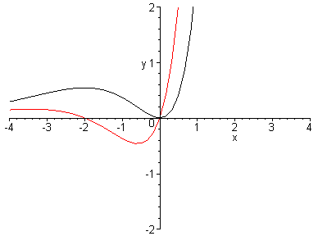

Which graph is f? Which is the graph of the derivative of f ? Compare the x-intercepts of the derivative function with the x-values of the local maximums and minimums of f
Now we will find the second derivative.
> D2f:=diff((Df),x);

> factor(%);

The following command is another way to find the second derivative of the expression f .
> diff(f,x$2);

Next, we find what some books call the "second order critical values". To do this, set the second derivative equal to 0 and solve in order to find the x-coordinates of possible inflection points.
> a:=solve(D2f=0,x);

> evalf(%);

These x-values are called a[1] and a[2]. Now we obtain the corresponding f(x)-values and graph the second derivative along with the original function.
> subs(x=a[1],f);

> evalf(%);

> subs(x=a[2],f);

> evalf(%);

> plot([f,D2f],x=-5..5,y=-1..3,color=[black,green]);

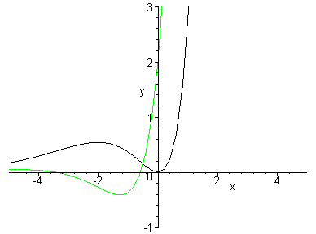

Compare the x-intercepts of D2f with the x-values of the inflection points of f on the graph. Where is f concave up? concave down?
Finally, it appears that f may have a horizontal asymptote on the left. Let's check.
> limit(f,x=-infinity);

0

So y = 0 is a horizontal asymptote of f.

Lab Assignment 8

Start the lab by putting your name on the first line. WRITE DOWN THE INSTRUCTION FOR EACH QUESTION AND ANSWER ALL QUESTIONS COMPLETELY IF YOU WANT FULL CREDIT!!!. When you complete the lab, hand in a printout of it and circle your answers.

1. Consider the function $F(x)=2 \text{sin}(x)+(\text{sin}(x))^{2}$ on the interval $\left[0, 2π\right]$

a) Find the first derivative of F. Then graph F and F' on the same graph.

b) Find all the critical numbers of F in the interval $\left[0, 2π\right]$.
Hint: Did Maple's solve command find all the critical numbers
(look at the graph)? You need to help Maple locate one of the
solutions by using fsolve(F'=0, x=a..b) where [a, b] is the
interval that contains the desired solution. What
are the critical numbers for F? _______________________

c) Find the second derivative of F. Then graph F and F" on the same graph.

d) What are the inflection points, (x, F(x))? _______________________

e) Find the points, (x, F(x)), that are local maximums _____________________

or local minimums of F __________________________.

2. Consider the function on the interval [-1, 6].

a) Find the first derivative of F. Then graph F and F' on the same graph.
Be sure to choose the y-values of the screen's dimensions so that the
extreme values of F and the zeros of F' are clearly visible.

b) What are the critical numbers for F?______________________________

c). Find the second derivative of F. Then graph F and F" on the same graph.

d) What are the inflection points (x, F(x))?____________________________

e) Find the points (x, F(x)) that are local maximums ____________________,

local minimums______________, an absolute maximum ______________

and an absolute minimum ________________

3. Let's go fly a kite! Your job is to maximize the area of the kite so that it will fly
better, faster, higher. To do the following problems, refer to the picture below.

x

a
a
y

x

z

b
b

a) Let a = 12 inches and b = 18 inches. Find x, y and z so that the area of the kite
is a maximum. Use Maple to develop the solution to this problem and write up
your response. (Hint: express y and z in terms of x using the Pythagorean
theorem. Find a function that represents the area of the kite, in terms of x and
maximize that function.)

b) Now find x, y, and z for the general case (a=a and b=b). Your answer should
have x, y, and z in terms of a and b. Use your answer to check part (a) and to
find x, y, and z for a = 15 and b = 21.

