Lab 7: Implicit Relationships

Goals
1. Students will differentiate implicitly with Maple using the implicitdiff command.
2. Students will graph non-functions using the implicitplot command.

Discussion
A relationship that is not solved for y, but instead has x's and y's intermingled throughout is called an implicit relationship. Occasionally these are functions, but more often they are not. In this lab we will look at implicit relationships, their graphs and derivatives.

Implicit Differentiation
First, use the with(plots) command to load more graphing options into Maple's memory.

> with(plots);

Here's an example of how to plot the equation implicitly using the implicitplot command.

> implicitplot(y^3+y^2-5*y-x^2=-4,x=-5..5,y=-5..5);

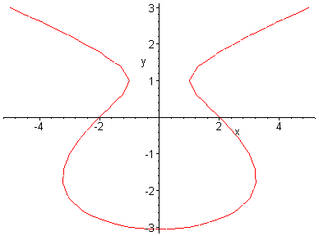

Note that the above equation is not a function because its graph does not pass the vertical line test.
Recall that the derivative of a function is undefined wherever vertical tangents occur. Let's take the derivative and find out exactly where the vertical tangents occur. We use the implicitdiff command as follows.

> implicitdiff(y^3+y^2-5*y-x^2=-4,y,x);

The derivative is undefined when the denominator is zero. Thus, to find y-values where the vertical tangents occur, set the above denominator equal to 0 and have Maple solve this equation as follows.

> solve(3*y^2+2*y-5=0,y);
(Note that we could have solved this equation by hand rather easily.)

To find the x-coordinates that go with these y-coordinates, first set the original equation, equal to zero to get . Then use the subs (or eval) command to evaluate this equation for .

> subs(y=-5/3,y^3+y^2-5*y-x^2+4=0);

Solve the resulting equation for x to obtain the desired x-values.

> solve(283/27-x^2=0,x);

To get decimal approximations of these x-values, use the evalf command.

> evalf(%);

Next, we repeat the process for .

> subs(y=1,y^3+y^2-5*y-x^2+4=0);

> solve(1-x^2=0,x);

So the points where the vertical tangent lines occur are ( , ), ( , ), (1, 1) and (-1, 1)
The equations of the associated vertical tangent lines are x = , x = , x =1, and x = -1.

In the final example, we graph the original equation, along with all of its vertical tangent lines.

> implicitplot({y^3+y^2-5*y-x^2=-4,x=1,x=-1,x=3.238,x=3.238},x=-5..5,y=-5..5);

