Lab 5: Secant and Tangent Lines

Goals
Students will investigate the derivative of a function numerically, graphically, and algebraically.

Discussion
We will use Maple to compute slopes of secant lines and use the limiting process to obtain the slope of the tangent line at a point on a curve. We will graph some secant lines and a tangent line of a curve. We will have Maple do the algebraic steps in the definition of the derivative.

Secant and Tangent Lines
Suppose f(x) is the following function.
> f:=x->x^3+x+1;

> a:=1;

> f(a);

The point (a, f(a))=(1, 3) is a point on the curve y = f(x). Let Q(x, f(x)) be another (different) point on the curve . The slope of the secant line is defined as follows.
> mPQ:=x->(f(x)-f(a))/(x-a);

Let's make a table (spreadsheet) of some values for the slopes, mPQ, when x approaches a = 1. Let h = x-a.

 | A | B | C
1
2
3
4
5
6
7
8
9
10

From the right column of the table it appears that the right-hand limit of mPQ is 4. Let's make a table for the left-hand limit.

 | A | B | C
1
2
3
4
5
6
7
8
9
10

The tables indicate that there is a two-sided limit for the slopes of the secant lines. This limit is the slope of the tangent line.
> m:=limit(mPQ(x),x=1);

Let's graph the function with the tangent line and the secant lines for x = 2, 1.5, and 1.25.
> t:=x->m*(x-a)+f(a);

> s1:=x->mPQ(2)*(x-a)+f(a);

> s2:=x->mPQ(1.5)*(x-a)+f(a);

> s3:=x->mPQ(1.25)*(x-a)+f(a);

> plot([f,t,s1,s2,s3],0..2,color=[black,red, green,blue, pink]);

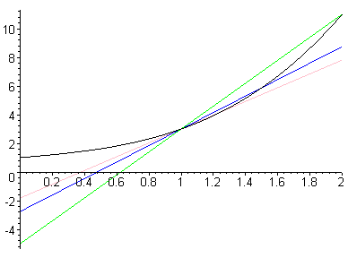

Difference Quotients
The definition of the derivative of the function f(x) at the point x = a is given by
f '(a)=. The derivative is also the slope of the tangent line to the curve y = f(x) when x = a. The slope of a secant line is and is called a difference quotient. In the following example Maple calculates the slopes for some secant lines and the slope of the tangent line.
> f:=x->1/(2*x+3);

> a:=1;

> (f(a+h)-f(a))/h;

> simplify(%);

> dq:=unapply(%,h);

dq is the difference quotient (defined as a function) for our function f(x). Notice that Maple will do algebra - it will simplify the difference quotient. Let's use dq to calculate slopes of some secant lines as x approaches 1. First, use x = 1.5, 1.1,and 1.01. The corresponding h-values, h = x-1, are 0.5, 0.1,and 0.01, respectively.
> dq(0.5); dq(0.1); dq(0.01);

Next we will try some x's left of 1, use x = 0.95, 0.99, and 0.999. The corresponding h-values are -0.05, -.01, and -.001, respectively.
> dq(-.05); dq(-.01); dq(-0.001);

Let's compare our calculations with Maple's limit of the dq's as h approaches 0.
> limit(dq(h),h=0);

> evalf(%);

Maple will graph the function and the tangent line on the same graph.
> with(student):
> showtangent(f(x),x=1,x=-1..3);

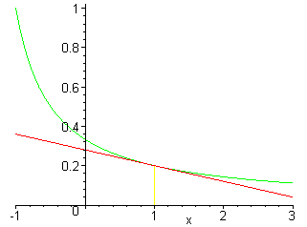
Lab Assignment 5

Start the lab by putting your name on the first line. WRITE DOWN THE INSTRUCTION FOR EACH QUESTION AND ANSWER ALL QUESTIONS COMPLETELY IF YOU WANT FULL CREDIT!!! When you complete the lab, hand in a floppy and a printout of your worksheet with your answers circled.

For each function f in numbers 1 and 2 below, do parts (a)-(f)
a) Find f(a)
b) Define the difference quotient (using h's) at the given point, a.
c) Find the slopes of the secant lines at the given point by using the difference quotient with h = 0.1, 0.01, 0.001, -0.01, and -0.001.
d) Find the slope of the tangent using the limit as h approaches zero.
e) Write a function for the secant line when h = 0.5 and a function for the tangent line.
f) Make a graph that contains the function, the secant line for h=0.5, and the tangent
line. Be sure to choose the screen size so that these three curves can be
distinguished. Note: the printer does not print yellow curves.

1. f(x) = with a = 1

2. $f(x)=\text{cos}(2x)$ with

