Lab 4: Evaluating Limits in Maple

Goals
1. Students will use Maple to evaluate two-sided limits, one-sided limits, and limits at infinity.
2. Students will use Maple to find vertical and horizontal asymptotes.

Discussion
Maple can compute various types of limits. It can evaluate limits from both positive and negative directions. Moreover, Maple recognizes undefined limits.

Limits

Finite and Infinite Values

Maple not only computes the limit of a function as x approaches a finite value but also as x goes to infinity, as shown in the following example.

> f:= (2*x+3)/(7*x+5);

> Limit(f, x=infinity );

> value(%);

Note the capital "L" on the limit command gives an output of the limit in mathematical notation, which allows you to make sure you entered the correct limit. To find the value of the limit, we employed the the value command. Use a lower case "l" on the limit command as follows to find the value of the limit in one step.

> limit(f, x=infinity );

Note that is a horizontal asymptote of . Also observe that the following graph of f seems to verify that the horizontal asymptote is indeed . Finally, note that although Maple plots the vertical asymptote of , it does not include the horizontal asymptote .

> plot(f(x),x=-10..10,y=-5..5);
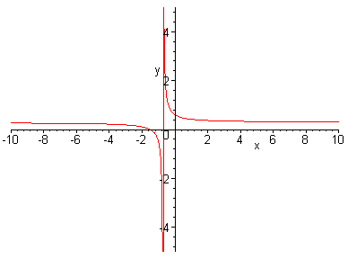

Positive and Negative Directions
You can also take the limit of an expression from both the positive and negative directions. Consider .

> Limit( tan(x+Pi/2), x=0, left);

> value(%);

> Limit( tan(x+Pi/2), x=0, right );

> value(%);

Note that is a vertical asymptote of . The below graph verifies this result.

> plot(tan(x+Pi/2),x=-5..5,y=-5..5);

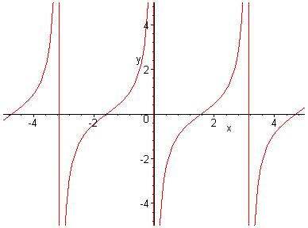

Also, since the left-hand limit and the right-hand limit are not equal, does not exist, as the following commands demonstrate.

> Limit( tan(x+Pi/2), x=0);

> value(%);

Finally, Maple can compute limits involving absolute values. Consider .
> Limit( abs(x-4)/(x-4) , x=4, right );

> value(%);

Lab Assignment 4

Start the lab by putting your name on the first line. Do the assignment in a new file (go to the file menu in Maple and click on "New"). Copy the below questions to your new file. When you complete the lab, hand in a printout of it. ANSWER ALL QUESTIONS COMPLETELY IF YOU WANT FULL CREDIT!!!

1. a) Use Maple to find the following limit: .

b) Graph the function using the plot command. Does the graph seem to verify the
limit that Maple gave you? Why or why not?

c) Does the function have a vertical asymptote? If so, what is it?

2. Use Maple to verify that is undefined. Find the left and right limits of
the function using Maple. Use these results to explain why the function is undefined.

3. a) Use Maple to evaluate the following limit:

b) Use the plot command to graph . Consider the behavior of the

graph as x goes to negative infinity. Does this graph seem to verify your answer
in part (a)? Why or why not?

4. a) Use Maple to evaluate the following limits: and

b) What are the horizontal asymptotes associated with the above limits? Graph
to justify your answer visually.

