Lab 3: Spreadsheets in Maple

Goal
Students will create spreadsheets in order to help them evaluate limits.

Spreadsheets
We use spreadsheets in Maple to create tables of values. To insert a spreadsheet, click on "Insert" and from there choose "spreadsheet" (see the picture below).

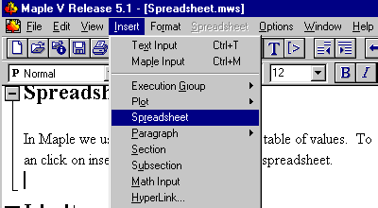

The following example demonstrates how to create a spreadsheet in Maple. This particular table will illustrate that . To label the columns in your spreadsheet, click on the box where you want to put your label, for example box A1. Next type in a single quote followed by your label and ending with a single quote and then press the Enter key. What you type in will show up near the top of the window, as shown in the figure below.
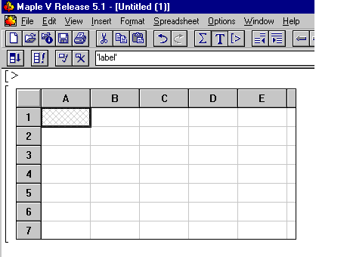

Notice the word 'label' above (with the single quotes included). After you press the Enter key the word "label" will appear in the A1 box in the spreadsheet.

Now we are going to create a table in Maple. Be sure to make this table in a new file.
Whenever you want to work with functions, expressions or variables in your table, they have to be in Maple's memory before you create the table. Execute the following commands in your Maple worksheet that you have just started (DO NOT EXECUTE THESE COMMANDS IN THIS WORKSHEET!!).

> f:=x->x^2-3*x+6;
> delta:=1;
> a:=1;

After executing the above commands in the new file, click on "Insert" then "Spreadsheet."

Put the following labels on your spreadsheet: column 1 'delta', column 2 'a +delta ' and column 3 'f(a +delta)'. Don't forget to put single quotes around your entries.

Now type "delta" in box A2, press Enter, and then type (a + ~a2) in box B2, press Enter, and last type evalf(f(~b2)) in box C2 and press enter. Notice you should have the numbers 1, 2 and 4 in these three boxes. Also observe that whenever you refer to a cell in your spreadsheet, you need to put a "~" before the name of the cell.

Here is what your spreadsheet should look like now.

 | A | B | C | D | E
1
2
3
4
5
6
7

Next, type the following in box A3: evalf(~a2/2) and then press Enter.

If you wish to fill in the rest of the table with the pattern set in place in boxes A3 and B2, here is what you do.
1.) Click and hold down the left mouse button on box A3, the one you want to pattern the rest of the boxes after in column 1, and drag down as far as you wish to go in order to highlight the column. For example, highlight the column down to box A10.
2.) Then click on the upper left button that looks like this:

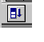
Next, do the same with B2, dragging down to box B10 and C2 dragging down to box C10. Your spreadsheet should now look like the figure below.

 | A | B | C | D | E
1
2
3
4
5
6
7
8
9
10
11

Notice that the table is set up so that the -values in column A are getting closer to zero from the right, which in turn means that the values in column B are getting closer to a = 1 from the right. So the values in column C are approaching . This limit appears to be about 4.

The next table investigates .

 | A | B | C | D
1
2
3
4
5
6
7
8
9
10

From this table, it appears that . Thus, since the left and right limits seem to the same, we can be fairly confident that .

Example: Now, suppose we want to use the above tables to approximate a number so that, for , < whenever <. To do this, look at the values underneath the column "f(a+)" and "f(a-)" in both tables and notice that the values 3.992248535 and 4.007873535 are both within .01 units of 4. These two numbers correspond to a of about 0.0078. So, based solely on the tables, the largest value of that will satisfy <.01 whenever < is about
Lab Assignment 3

Start the lab by putting your name on the first line. WRITE DOWN THE INSTRUCTION FOR EACH QUESTION AND ANSWER ALL QUESTIONS COMPLETELY IF YOU WANT FULL CREDIT!!! When you complete the lab, hand in a floppy and a printout of your worksheet with your answers circled.

1. a) Use a spreadsheet to investigate the left and right limits of as x
approaches = 2. You may use two tables to investigate the right and left limits individually (as above), or you might want to combine all the necessary information in one table. Either way, your table(s) should have at least nine values for and be labeled as in the above demonstration.

b) Use your table(s) in part (a) to approximate a number so that, for =0.1,
< whenever <

2. a) Repeat part (a) from problem number 1 for the following limit:
(Note that the is entered in Maple as "sqrt(x)").

b) Based on your table, estimate the limit in part (a) to the nearest hundredth.

c) Repeat part (1b), with = 1 and L equal to your estimate of the limit that you
found in part (2b).

