Lab 2: Functions, Expressions, and Limits

Goals
1. Students will apply the appropriate Maple commands to define, evaluate, and graph
Maple functions and Maple expressions.
2. Students will evaluate limits using Maple.

Discussion
There are two ways to input mathematical functions into Maple's memory. The first is to define the function as what Maple calls an expression. The second method is to define the function as what Maple calls a function. The commands for functions and expressions are different. If Maple will not execute your command, check that the input mode (function or expression) and the command mode are the same.

Functions and Expressions
The following is an example of how to define the function as a MAPLE EXRESSION.
> f:=x^2+2*x+3;

To evaluate an expression at x = 2 use one of the following commands.
> eval(f,x=2);

> subs(x=2,f);

Do not use f(2). Maple reserves this notation for functions.

The following shows how to define the function as a MAPLE FUNCTION.
> f:=x->x^2+2*x+3;

The "$→$" symbol is created by the minus sign followed by the greater than sign. Now the standard function notation, f(2), is used to evaluate the function f(x) at x = 2.
> f(2);

When f is defined as a function (using x$→$), Maple recognizes f(x). When f is defined as a expression (with no x $→$), Maple thinks f(x) is nonsense.

The Relationship Between Functions and Expressions
If you have defined f as an expression, you can convert it to a function by using the unapply command. The following example shows how to turn the expression f into a function g and how to evaluate both f and g at x = 3.
> f:=x^2+3;

> g:=unapply(f,x);

> g(3);

> eval(f,x=3);

If you have defined g as a function in Maple, you can get Maple to think of g as an expression by entering g(x). For example, consider the following function.
> g:=x->cos(x);

Use g(x), as opposed to just g, in the Maple commands that require expressions. For instance, to use the eval command (which works only with expressions), enter the following.
> eval(g(x),x=Pi/4);

Note that if you had entered "eval(g,x=Pi/4);", Maple would have not performed the desired command.

Maple Commands
The commands for graphing functions and expressions are slightly different. The following example demonstrates how to get Maple to plot a Maple expression.

> f:=x^2-4;

> plot(f,x=-5..5,y=-10..25);

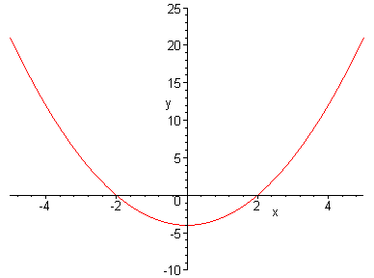

Note that, when f is defined as an expression, the "x =" and "y =" are included when specifying the domain and range. To plot a function g (see the following example), do not include "x =" and "y =".
> g:=x->x^2-4;

> plot(g,-5..5,-10..25);
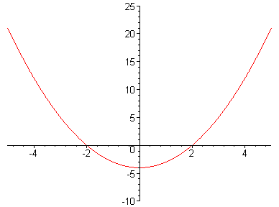

The Maple commands evalf, expand, simplify, and factor require expressions for arguments.
> factor(f);

> factor(g(x));

> factor(g);

The last command above failed to work because g is not defined as a Maple expression.

Limits
We will investigate the following limit: .
> f:=x->sin(3*x)/x;

> plot(f,-1..1);

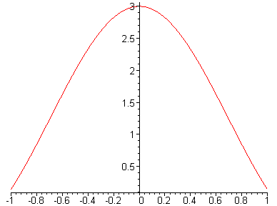

> f(0);

Error, (in f) division by zero

Note that, although the function f is undefined at x = 0, we can still investigate f(x) when x is close to 0. Consider the above graph. What is f(x) close to when x is close to zero but not quite equal to 0? Let's calculate some values for f(x) when x is close to 0.
> f(0.1); f(0.01); f(0.001);

> f(-0.1); f(-0.01); f(-0.001);

It appears that f(x) approaches the value of 3 as the x approaches 0.
Let's see how Maple evaluates limits using the limit command.
> limit(f(x),x=0);

Discontinuous Functions
Let f(x) be the following piecewise-defined function.
> f:=x->piecewise(x<2,x^2,2*x+3);

> plot(f,-5..5,numpoints=200,style=point);

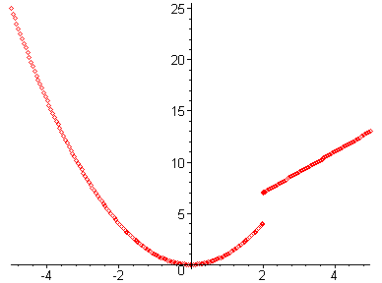

We use "style=point" above to prevent Maple from connecting points that should not be connected. Let's have Maple do the left-hand and the right-hand limits of f as x appoaches 2.
> limit(f(x),x=2,left);

> limit(f(x),x=2, right);

> limit(f(x),x=2);

The two-sided limit does not exist since the left-hand limit is different from the right-hand limit.

Next, let's make Maple plot the greatest integer function [[x]].
> f:=x->floor(x);

> plot(f,-5..5,numpoints=200,style=point);

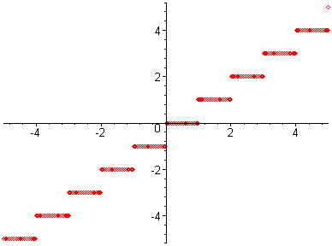

> limit(f(x),x=2,left);

> limit(f(x), x=2,right);

Lab Assignment 2

Start the lab by putting your name on the first line. Do the assignment in a new file (go to the file menu in Maple and click on "New"). Copy the below questions to your new file. When you complete the lab, hand in a printout of it. ANSWER ALL QUESTIONS COMPLETELY IF YOU WANT FULL CREDIT!!!

1. a) Graph the function by defining g as a function in Maple.
(Note that a 10 by 10 viewing window is inappropriate for this function.
Define your domain and range so that you can see all of the "peaks" and
"valleys" of this graph.)

b) Use Maple to find g(-2.35).

2. a) Graph , by defining f as an expression in Maple .

b) Use Maple to find f(231.2).

3. a) Graph f(x) = , by defining f as a function in Maple and using the
domain [-0.2, 0.2].

b) We wish to find . Use Maple to find f(x) for
x = +0.1, +0.01, +0.001, and +0.0001.

c) Use Maple's limit command to find the limit.

4. a) Graph f(x) = cos(1/x) as a function in Maple with domain [-0.2, 0.2].

b.) Use Maple to find f(x) for x = +0.1, +0.01,+0.001, and +0.0001.

c.) Use Maple's limit command to find .

d.) Is Maple's limit in part (c) reasonable? Why or why not?
What should you say about ? Explain your answer.

