Pond Water Nutrient Enrichment Exercise 10-1

Introduction

Cultural eutrophication is a common problem in many of our freshwater streams, ponds, and lakes. It is brought about by the unwanted addition of plant nutrients containing nitrogen and phosphorous to aquatic systems. Normally these nutrients are in short supply and limit the growth of algae. When abnormal amounts of these compounds are added the algae and bacteria populations explode, available dissolved oxygen is depleted, and other residents in the system are stressed and frequently die.
Nitrogen and phosphorus containing compounds are added to aquatic systems by human activities of many types. They can enter in freshwater runoff from farm fields, golf courses, and sewage treatment plants. Once in the system they can persist in sediments until cleared by microorganisms.
In this lab you will run an experiment to see what effect the addition of plant fertilizer will have on the algae found in pond water. To accomplish this, you will add a fertilizer solution containing phosphate and nitrogen compounds to pond water samples and incubate them for two weeks.

Materials
Per lab table:
- metric balance
- label tape
Per student:
- 1 - wax marker
- 1 - spoon
- 1 - weighing boat
- 20N-20P-20K plant food (~1 gram)
- 1 - 125 ml flask
- 1 - 100 ml graduated cylinder
- 1- 125 ml beaker
- 1 - test tube rack
- 5 – 15 ml test tubes with slip on caps
- 1 – 1 ml pipette
- 1 – 10 ml pipette
- 1 – blue 1 ml pipette pump
- 1 – green 10 ml pipette pump
- 1- Pond Water Sample (~100ml)
Labeled On Back Counter:
- 1-Carboy RO Water

Experimental Procedure

- Prepare a Fertilizer Stock Solution.
- Place a weighing boat on a balance and tare it.
- Using the spoon, add 0.5 g of dry plant food (20%N-20%P-20%K) to the boat until balanced.
- Using the graduated cylinder, place 100 ml RO (reverse osmosis) water into a 125 ml flask labeled fertilizer stock solution.
- Pour the 0.5 g plant food (20%N-20%P-20%K) into the 100 ml RO water in the 125 ml flask; swirl gently to mix until completely dissolved.
- Determine the concentration of N-P-K in the stock solution in mg/L.
  - Convert % N-P-K into decimal equivalent.
  - Multiply the decimal equivalent by the amount of fertilizer power used in the stock solution converted to milligrams (mg) to determine the weight of N-P-K in the solution.
  - Divide the weight of N-P-K in the solution by the volume of water in the solution converted to liters (L) to determine the concentration of N-P-K in the solution.

a.
b.
c.

Prepare a 10X Serial Dilution of Fertilizer in pond water in labeled tubes.
- Place five 15 ml test tubes in a test tube rack.
- Using the wax marker, label your tubes 1-5.
- Get ~75 ml of pond water in a 125 ml beaker.
- Using a 10 ml pipette and a green pipette pump (see Figures 2 and 3), add 10 ml of pond water to tubes one through five.
- Using a 1 ml pipette and a blue pipette pump, add 1 ml of the Fertilizer Stock Solution to tube #5. Stir the tube using the pipette to mix the solutions.
- Using the 1 ml pipette and pump, transfer 1 ml of the tube #5 solution to tube #4, stir, and flush the pipette.
- Using the same transfer and mix procedure (see Figure 4):
  - Transfer 1 ml from tube #4 to tube #3.
  - Transfer 1 ml from tube #3 to tube #2
  - Do NOT transfer any solution to tube #1.

Figure 4. Serial Dilution

Fertilizer Stock Solution

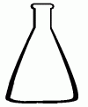

Transfer 1 ml of

stock solution

to tube 5

Start with 10 ml of Pond Water in each tube

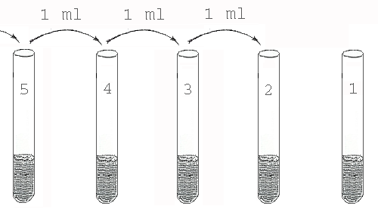

Do Not Transfer

1 ml of solution from tube 2 into tube 1

Clean Up
- Discard remaining Fertilizer Stock Solution and rinse the 125 ml beaker.
- Discard used pipettes and weighing boat.

Incubate
- Cap the tubes using slip on caps.
- Use some tape to label the test tube rack with your class session and name.
- Place the rack in an Eco-box incubator set at 12 hours of light per 24 hour period and 32⁰ centigrade (ideal conditions for algal growth).

Questions

- What are three alternative hypotheses for this experiment?

H₀:

H₁:

H₂:

- What is the independent variable of this experiment?

- What is the purpose of the serial dilution?

- Determine the concentrations of nitrogen and phosphorus (mg/L) added to the 5 treatments.
 | 5 | 4 | 3 | 2 | 1
Nitrogen (mg/L)

Phosphorus (mg/L)

Potassium (mg/L)

- What is the dependent variable of this experiment?

- What do you predict will be the results of this experiment? Explain why.

P₀: If H₀ is true then:

P₁: If H₁ is true then:

P₂: If H₂ is true then:

- What is the purpose of treatment #1?

- Why is it important to use loose fitting caps and NOT air tight ones?

- What are the control variables in this experiment?

- What is Eutrophication?

- Where does nitrate and phosphate runoff come from in an urban environment?

Pond Water Nutrient Enrichment Lab: Results and Analysis

Introduction
Two weeks ago, you set up six test tubes with a 10x serial dilution of phosphorus and nitrogen nutrients. Tubes 2-5 were each 10x more concentrated than the preceding tube. Tube one was the untreated control and contained no additional nutrients. Finally, each tube was inoculated with an equal amount (10 ml) of pond water.
Today, you will compare these tubes and determine if the nutrient concentrations affected algal and bacterial growth.

Materials
Per student:
- Incubated Serial dilution tubes in a test tube rack
- Growth Comparator
- Graph paper
Results

A. Growth Comparison-Individual Results
Hold each tube against the center of the Algal Growth Comparator, examine each very carefully, and evaluate the quantity of microbial growth in the tube using the following scale: 0 = no growth, 1 = very little growth, 2 = some growth, 3 = considerable growth,
4 = extensive growth. Be consistent with your judgments. Judge the intensity of the color.

Algal Growth Comparator
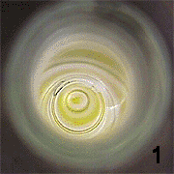 | 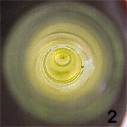 | 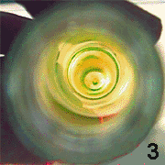
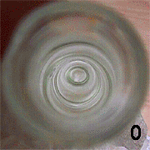 | Place Tube Here | 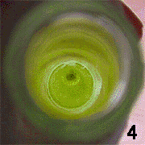
Individual Results
Treatment # | Growth Group #  (0-4)
1
2
3
4
5

C. Algal Growth Comparison-Class Results
Record your individual group data in the chart on the board. Copy the class data into the following table.
Growth Group # Class Data
Replicate | Treatment 1 | Treatment 2 | Treatment 3 | Treatment 4 | Treatment 5
1
2
3
4
5
6
7
8
9
10
11
12
13
14
15
16
17
18
19
20
21
22
23
24
Mean

D. Algal Growth Comparison-Graphing Class Results
Make a line graph showing the class totals for growth.
Rather than playing “connect the dots”, draw a line showing the pattern indicated by the five data points.

Algae/Bacterial Growth-Averages
12345

NPK Treatments
Study Questions

- Interpret your class growth data explaining the relationship between nutrient concentration and algal growth.
- What does tube #1 show you regarding the original pond water?

- How do these actual results compare to your original predictions (hypotheses)?
P₀:
P₁:
P₂:
- Why is tube #5 an example of eutrophication in a test tube?

